Mass Broadcast System

📢 What Is a Mass Broadcast System?
# Source: AI Source: Provided by: [Data Path: Persons Table -> ID Column: 1, Name_En Column: Motasem Essam] -> From: [Chatgpt (GPT‑5 Mini)] on [1/21/2026]
A mass broadcast system is a communication system designed to send the same message or content to a large number of people simultaneously, often without knowing individual recipients’ identities.
🧠 Think of it like a loudspeaker or radio — one sender, many listeners.

🧩 Key Features:
# Source: AI Source: Provided by: [Data Path: Persons Table -> ID Column: 1, Name_En Column: Motasem Essam] -> From: [Chatgpt (GPT‑5 Mini)] on [1/21/2026]
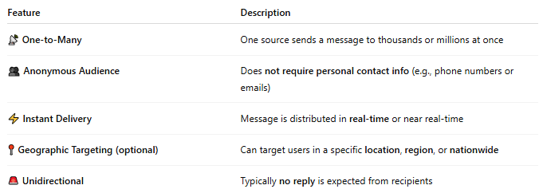

Feature | Description
📡 One-to-Many | One source sends a message to thousands or millions at once
👥 Anonymous Audience | Does not require personal contact info (e.g., phone numbers or emails)
⚡ Instant Delivery | Message is distributed in real-time or near real-time
📍 Geographic Targeting (optional) | Can target users in a specific location, region, or nationwide
🚨 Unidirectional | Typically no reply is expected from recipients

📲 Examples of Mass Broadcast Systems:
# Source: AI Source: Provided by: [Data Path: Persons Table -> ID Column: 1, Name_En Column: Motasem Essam] -> From: [Chatgpt (GPT‑5 Mini)] on [1/21/2026]
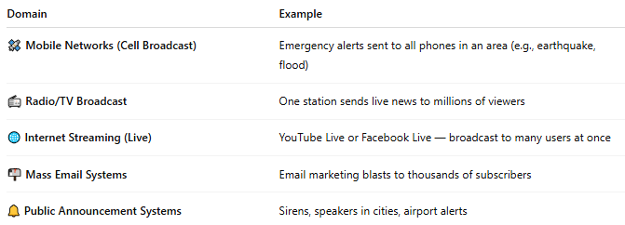

Domain | Example
🛰️ Mobile Networks (Cell Broadcast) | Emergency alerts sent to all phones in an area (e.g., earthquake, flood)
📻 Radio/TV Broadcast | One station sends live news to millions of viewers
🌐 Internet Streaming (Live) | YouTube Live or Facebook Live — broadcast to many users at once
📬 Mass Email Systems | Email marketing blasts to thousands of subscribers
🔔 Public Announcement Systems | Sirens, speakers in cities, airport alerts

📡 Cell Broadcast = A Mass Broadcast System:
# Source: AI Source: Provided by: [Data Path: Persons Table -> ID Column: 1, Name_En Column: Motasem Essam] -> From: [Chatgpt (GPT‑5 Mini)] on [1/21/2026]
Cell Broadcast (SMS-CB) is a telecom example of a mass broadcast system:
- 🚫 No phone number needed
- 📱 Sent to all devices in range of a cell tower
- ⚠️ Used for disasters, weather alerts, or civil defense

🆚 Mass Broadcast vs Other Messaging:
# Source: AI Source: Provided by: [Data Path: Persons Table -> ID Column: 1, Name_En Column: Motasem Essam] -> From: [Chatgpt (GPT‑5 Mini)] on [1/21/2026]
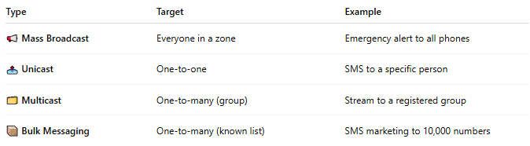

Type | Target | Example
📢 Mass Broadcast | Everyone in a zone | Emergency alert to all phones
📤 Unicast | One-to-one | SMS to a specific person
🗂️ Multicast | One-to-many (group) | Stream to a registered group
📦 Bulk Messaging | One-to-many (known list) | SMS marketing to 10,000 numbers

✅ Benefits of Mass Broadcast Systems:
# Source: AI Source: Provided by: [Data Path: Persons Table -> ID Column: 1, Name_En Column: Motasem Essam] -> From: [Chatgpt (GPT‑5 Mini)] on [1/21/2026]
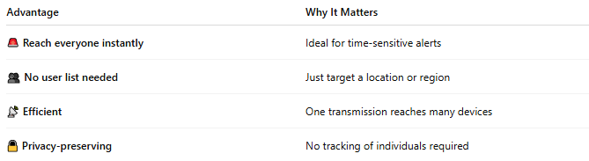

Advantage | Why It Matters
🚨 Reach everyone instantly | Ideal for time-sensitive alerts
👥 No user list needed | Just target a location or region
📡 Efficient | One transmission reaches many devices
🔒 Privacy-preserving | No tracking of individuals required

📖 Summary:
# Source: AI Source: Provided by: [Data Path: Persons Table -> ID Column: 1, Name_En Column: Motasem Essam] -> From: [Chatgpt (GPT‑5 Mini)] on [1/21/2026]
A mass broadcast system is:
- 📢 A one-to-many communication platform
- 🚫 Doesn’t rely on personal contact info
- ⏱️ Used for urgent, wide-scale notifications
- 🛰️ Common in emergency services, media, and telecom

